-------- CLASS COPY -------
Microscope Skills Lab

Step 1: Identifying Microscope Parts
- Go to the following website:
http://www.wisc-online.com/Objects/ViewObject.aspx?ID=BIO905
  - After you read the brief intro, click next to view a labeled microscope. Review the image for a minute or two.
  - Click next and drag each part name to its proper location, then label the diagram on your data sheet. When finished click next.
  - Read through the next section of slides and answer the questions on your data sheet. When finished click next.
  - Quiz yourself at the end of the presentation

Step 2: Calculating Microscope Magnifications
- Observe the letter “e” that has been prepared under the microscope using the LOW power objective (marked in yellow), and answer the questions on your data sheet.
  - You can use both the coarse adjustment knob and the fine adjustment knob to bring the specimen into focus.
  - DO NOT remove the slide from the stage.
- With the letter e in focus, switch the magnification by rotating the objective lenses from low to HIGH power (marked in blue). Be sure that the objective lens clicks into place.
  - Once on high power you may ONLY use the fine adjustment knob to bring the specimen into focus.
- Determine the total magnification for each microscope and answer the questions that follow.
  - HINT: Total magnification is determined by multiplying the eyepiece magnification by the objective lens.
- Reset the specimen to be viewed under the low power objective for the next group.

Name: _______________________________________________________ Date: _____________________ Per: _____________

Microscope Skill Lab

Step 1: Microscope Parts
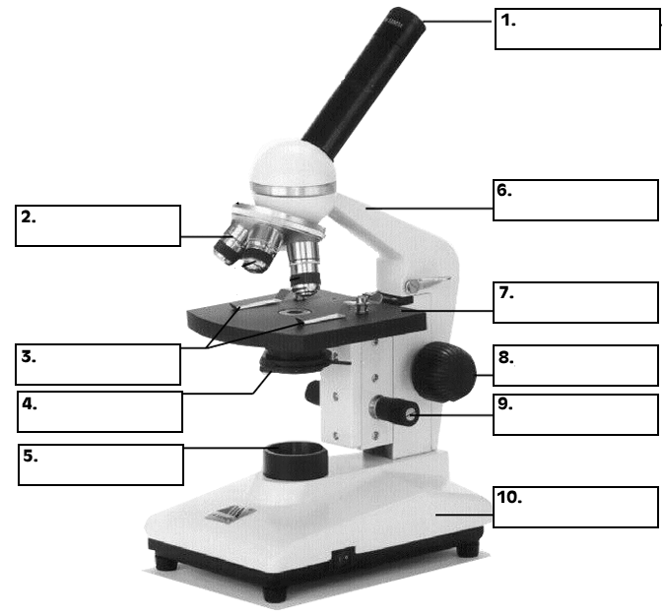
Label the diagram below:

- Click on the light source (lamp).
  - When would you use more light? __________________________________________________
  - When would you use less light? ____________________________________________________
- Click on the oculars.
  - What magnification are the oculars (eyepiece)? __________________________________
  - When looking through oculars, what should you do? ____________________________
- Click NEXT
  - When first focusing on an image, which objective lens would you start with? _______
  - Which knob do you use to focus the image under low power? _________________________
  - What magnification are the low power objectives? _____________________________________
- Click NEXT
  - What magnification is high power? ______________________________________________________
  - Which knob would you use to focus an image under high power? ____________________
- Click NEXT – skip this section, we will not use oil immersion

- Click NEXT
  - What should be done when putting away your microscope?

___________________________________________________________________________________________________
___________________________________________________________________________________________________
___________________________________________________________________________________________________

Step 2: Microscope Magnification

- View the letter “e” under the microscope using the low power objective.
  - What do you notice about the appearance of the letter “e” through the microscope? Describe how that is different from what appears on the slide when it is just sitting on the microscope stage. ________________________________________________________________________________________________________________________________________________________________________________________________________
- Switch from low to high power.
  - What did you notice about the field of view as you moved from low to high power? _______________________________________________________________________________________________
- What is the total magnification for low power? High power? SHOW YOUR WORK.

- Fill in the chart below for sample compound microscopes. Assume the eyepiece is always 10x unless told otherwise
Microscope | Eyepiece | Low power objective lens | Total low power magnification | High power objective lens | Total high power magnification
A |  | 4x |  | 40x
B |  | 10x |  | 46x
C |  | 8x |  | 53x

  - Which microscope gives you the highest magnification under low power? __________
  - Which microscope gives you the highest magnification under high power? __________
  - Which microscope magnification would you initially use to locate a specimen on a slide? Explain. __________________________________________________________________________________
____________________________________________________________________________________________________
  - Which microscope image would give you the smallest field of view and the image with the most detail? ____________

